**Day 4 - Dynamic Frontend Components**

**Introduction:**

This document provides a detailed overview of the E-commerce Furniture Website project. The platform focuses on selling furniture items and includes features like dynamic routing, reusable components, add-to-cart functionality, real-time notifications, checkout processes, and real-time stock updates integrated with Sanity CMS.

**1. User Authentication**

* Integrated Firebase authentication for secure login and registration.
* Features include:
  + Google and email-based authentication.
  + Password reset functionality.

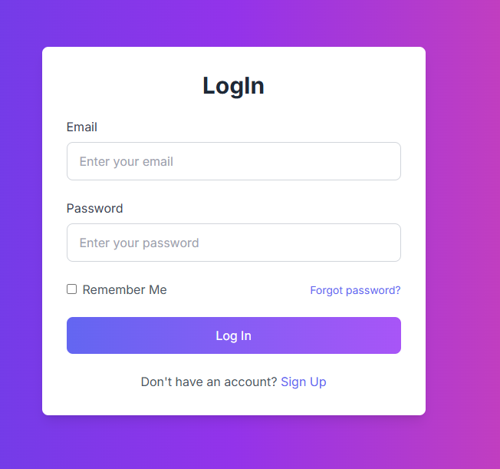

**2. Product Details with Dynamic Routing**

Utilized Next.js for dynamic routing, enabling each product to have a dedicated page displaying:

* + Product Title
  + Detailed Description
  + Pricing
  + Availability Status
  + High-resolution Images
  + Related Products

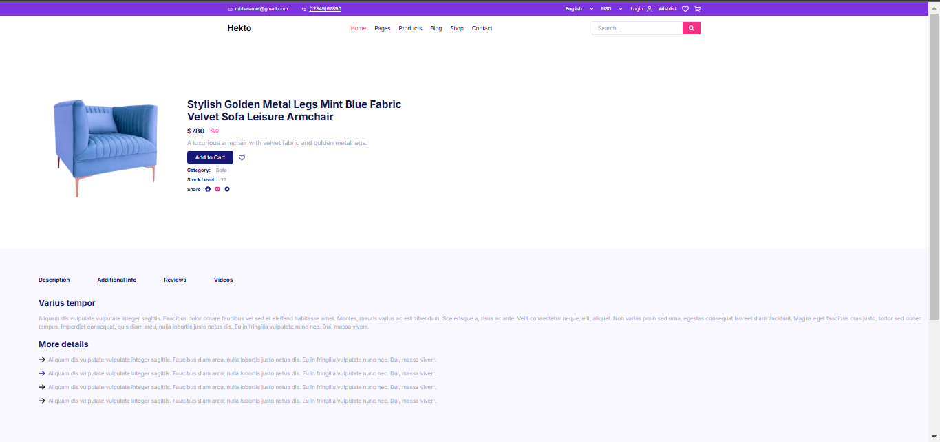

**3. Modular and Reusable Components**

* Developed reusable UI components to enhance maintainability and scalability.
* Examples include:
  + Product Card Component
  + Navbar Component
  + Sidebar Filters Component
  + Footer Component

**4. Cart Functionality with Real-time Updates**

* Users can add/remove products dynamically.
* Features include:
  + Live cart updates reflecting item quantity and price changes.
  + ○ Display of total items and price in the cart.
  + Visual indicator displaying cart item count.

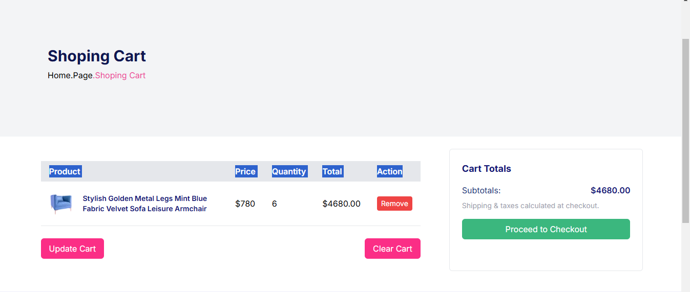

**5. Secure Checkout and Payment Gateway Integration**

* Designed a multi-step checkout page featuring:
  + Billing and shipping address forms.
  + Order summary before final confirmation.
  + Payment processing via Stripe.
  + Order status tracking for users.

**6. Real-time Inventory Management**

* Implemented inventory tracking using Firebase Firestore.
* Features include:
  + Stock updates triggered upon order placement.
  + Automatic prevention of purchasing out-of-stock items.

**FAQ Section**

* Developed a dedicated FAQ page addressing common user concerns about orders, payments, and returns.

**Tools and Technologies Used**

* **Frontend:** Next.js, Tailwind CSS
* **Backend:** Firebase Firestore
* **State Management:** React Context API
* **Authentication:** Firebase Authentication
* **Payments:** Stripe API
* **Notifications:** React Toastify

**Conclusion**

The ShopEase E-commerce platform successfully integrates a user-friendly shopping experience with robust backend management. The implementation of dynamic routing, reusable components, and secure transactions ensures a scalable and efficient web application.

**Final Checklist**

|  |  |  |  |  |
| --- | --- | --- | --- | --- |
| **Fronted**  **Component**  **Development** | **Styling and**  **Responsive** | **Code Quality** | **Documentation**  **And**  **Submission** | **Final Review** |
| **✓** | **✓** | **✓** | **✓** | **✓** |